NECANN Exhibitor Social Resources

Please use these branded images for NECANN Boston. Below are directions for posting multiple images so you can add your info to the post (Company logo & Booth number, speaker photo & decision info, etc). You can also just lay that information over the skyline picture if you prefer to use a single image for your post.
How To Put Multiple Pictures In One Instagram Post 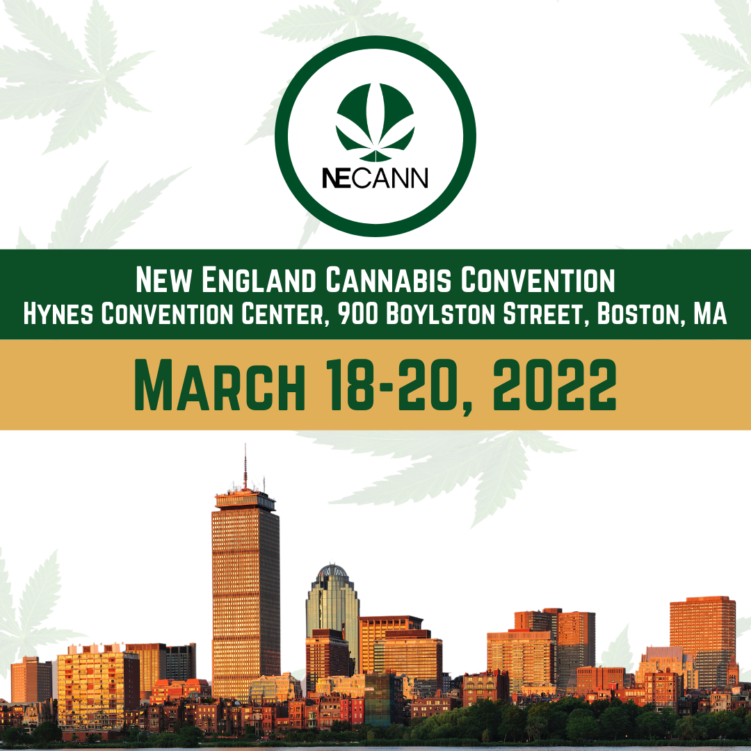
- Open Instagram and tap the + at the top of the screen to create a new post.
- Choose the option POST.
- Tap the multiple photo icon above your photo gallery.
- Choose the photos that you want to appear in your post. They will be numbered in the order that you choose them (which is the order in which they will appear in your post). Please use NECANN branding for the 1st photo, and the photo that best represents your business for the next photo! (1) NECANN (2) Personal photo
- When you are finished selecting your photos, tap Next.
- Here you can double check that you chose the right photos. Then, tap Next and type in your caption, add NECANN hashtags, tag @necannacon and other accounts, and add the convention location.
- Tap Share to post to your Instagram profile.

How To Put Multiple Pictures In One Facebook Post
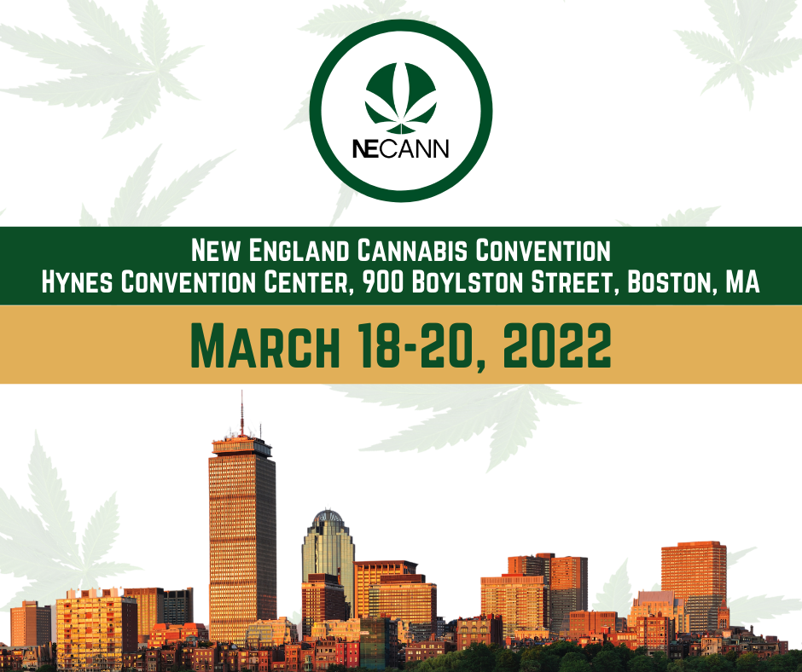
- Tap the Facebook app to open it.
- In the status field at the top of the News Feed, tap Photo.
- Tap the thumbnails of the photos you want to add to the status. Please use NECANN branding for the first one, and the second your personal business photo.
- Use the Done button to open the preview screen.
- Review the other available options: tag friends, TAG @NECANNCON, AND check-in to your convention location.
- When you're ready, select Share.

How To Put Multiple Pictures In One Twitter Post
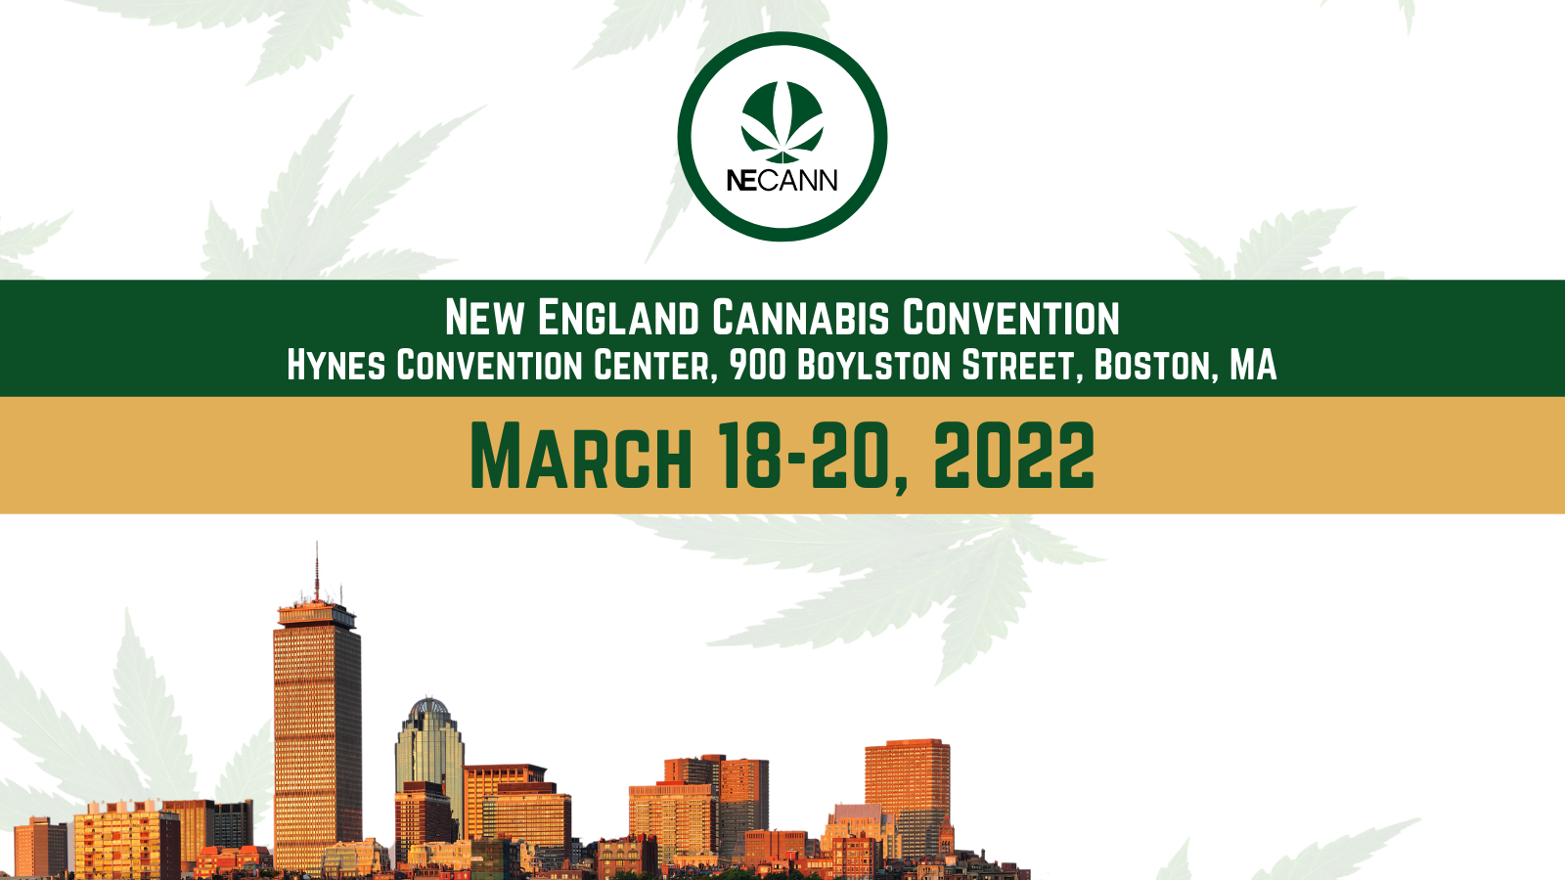
- Click the “Compose” icon to create a new Tweet.
- Click the “Image” icon and choose the first image of your collage (NECANN branding from your phone library: it will be inserted into your Tweet.
- Click the “Image” icon again, and this time, choose your personal business image to be inserted into the Tweet.
- Add NECANN hashtags, the event location, and tag @NE_CANN .
- Tap the location icon in the Tweet compose box to open a list of places that you can choose. Select the location where the convention is held.
- Post your Tweet!

How To Put Multiple Pictures In One LinkedIn Post
- To post a multi-image update, start by opening the application.
- Within the Home feed, tap the area that reads “share an article, photo or idea” and enter your post text.
- Then select the camera icon to choose (1) NECANN branding photo and (2) personal business photo.
- Add NECANN hashtags, convention location, and tag @NECANN.
- Post!

